FRESHLY MADE DOUGHNUTS
10 OAKFIELD AVENUE BARNOLDSWICK LANCASHIRE BB18 5JP
TEL: 01282 850520 EMAIL david_inman@sky.com
ALL EVENTS CATERED FOR
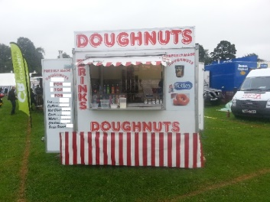
DOUGHNUTS FRESHLY PREPARED IN FRONT OF YOUR EYES!!
FULL PULIC LIABILITY INSURANCE 5 OUT OF 5 HYGIENE RATED
PROUD TO SUPPORT THE AGRICULTURAL SHOWS

